**Chemistry: 4. Acids and Bases**

***Please remember to photocopy 4 pages onto one sheet by going A3→A4 and using back to back on the photocopier***

**Part (i)**

**Syllabus**

**OC18** Use litmus or a universal indicator to test a variety of solutions, and classify these as acidic, basic or neutral

**OC19** Investigate the pH of a variety of materials using the pH scale

**OC20** Give examples of everyday acids and bases.

**OC35** State the names and formulae of common strong acids and bases: H2SO4, HCl, NaOH, Ca(OH)2, and understand that alkalis are soluble bases

**OC36** Show the neutralisation of an acid with a base using an indicator

**OC37** Understand that, when an acid reacts with a base, a salt and water are formed

1. HCl + NaOH → NaCl + H2O (word equation O.L.)
2. 2HCl + CaCO3 → CaCl2 + CO2+ H2O (word equation O.L.)

**OC38** Titrate HCl against NaOH, and prepare a sample of NaCl.

**Student Notes**

**Both acids and bases are corrosive**

**Examples of everyday acids and bases**

**Acidic**: citric acid, e.g. lemon juice, orange juice, apples, sour milk, vinegar, fizzy drinks and tea.

**Neutral**: pure water

**Basic**: tooth paste, lime water, bread soda, toothpaste, window cleaner and caustic soda.

**Indicators**

An indicator is a compound which shows, by colour change, whether a substance is acidic or basic.

Litmus paper is an example of an indicator.

**Experiment:**

**Use litmus or a universal indicator to test a variety of solutions, and classify these as acidic, basic or neutral**

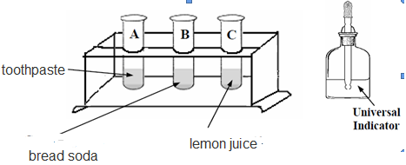

**Equipment**:

* Litmus paper / universal indicator
* various household substances

**Procedure**:

Drop a spot of universal indicator onto each substance and note the colour change.

**Result**:

Using litmus paper: acids turn litmus from blue to red, bases turn litmus from red to blue.

**The pH scale**



Litmus tells us if a substance is acidic or basic but not *how* acidic or basic the substance actually is.

The pH scale allows to quantify (put a number) on the acid or base.

The pH of a solution can be found using:

(i) A pH meter

(ii) Universal indicator solution

(iii) pH paper (paper soaked in universal indicator solution)

**The pH scale tells us how acidic or basic a solution is**

pH greater than 7: the substance is alkaline

pH less than 7: the substance is acidic

pH 7: the substance is neutral

**Experiment: To investigate the pH of a variety of materials**

Apparatus: rack of test tubes

Chemicals: variety of substances – see ‘Examples of everyday acids and bases’ above

**Procedure**:

1. Put substances in test tubes (they must be dissolved in water if they are not a liquid).
2. Pour in a few drops of universal indicator and shake well (the colour will change according to how acidic or basic the substance is).
3. Use the pH scale to write up results.

**Universal Indicator pH Scale**

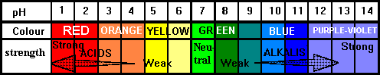

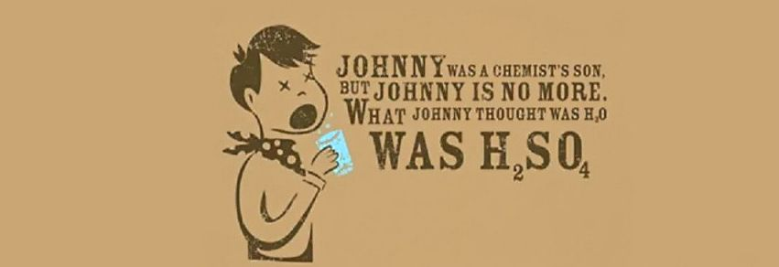**Acids and Bases part (ii)**

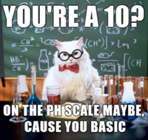

**Common strong acids and bases**

|  |  |  |  |
| --- | --- | --- | --- |
| **Acids** | | **Bases** | |
| hydrochloric acid | HCl | sodium hydroxide | NaOH |
| sulfuric acid | H2SO4 | calcium hydroxide | Ca(OH)2 |
|  |  | calcium carbonate | CaCO3 |

**Alkalis are bases that are dissolved in water**

Sodium hydroxide (caustic soda) is an example of an alkaline substance.

**Neutralisation**

The properties of an acid are counteracted or neutralised by a base; this type of reaction is called a neutralisation reaction.

**When an acid reacts with a base the hydrogen in the acid is replaced by a metal and a salt is formed**

Sodium and calcium are examples of metals

General formula to represent neutralisation reaction:

**Acid + Base → Salt + Water**

**Example 1**

hydrochloric acid + sodium hydroxide → sodium chloride + Water

HCL + NaOH → NaCl + H2O

**Example 2**

hydrochloric acid + calcium carbonate → calcium chloride + CO2  + Water

2HCl + CaCO3 → CaCl2 + CO2 + H2O

**Titration**

A titration is a method of finding out the exact amount of acid required to ***just*** neutralise a certain volume of a base.

**To titrate hydrochloric acid (HCl) and sodium hydroxide (NaOH) and prepare a sample of sodium chloride (NaCl)**

Apparatus: As shown in the diagram

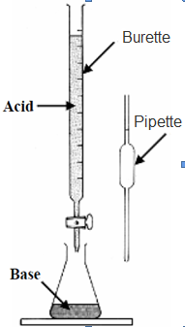Chemicals: dilute hydrochloric acid, dilute sodium hydroxide

**Method:**

1. Set up apparatus as shown in diagram.
2. Note the volume of hydrochloric acid in the burette and put 25 cm3 of sodium hydroxide into the conical flask using the pipette for accurate measurement.
3. Use pH paper to measure the pH of the base.
4. Slowly add the acid into the conical flask until the liquid in the conical flask reaches a pH of 7 (the liquid is now neutral).
5. Note the new reading on the burette. Take the final reading from the initial reading to calculate the amount of acid required to neutralise the base.
6. Pour the contents of the conical flask into an evaporating dish and evaporate it to almost dryness.
7. Let the solution cool - crystals of NaCl will form in the dish.

Result: White crystals of sodium chloride are formed.

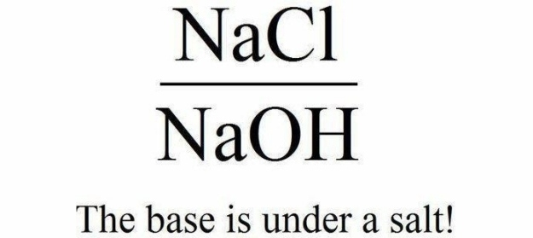

Red alert! Red alert!

**Exam Questions**

|  |  |
| --- | --- |
| Acid | Base |
|  |  |

1. [2006 OL] [2008 OL] [2010 OL]

|  |
| --- |
| Vinegar  Water  Oven Cleaner |

Many substances found in the home are acids or bases.

Complete the table below identifying one acid and one base from the list on the right.

1. [2007 OL][2007]

Describe, with the help of a labelled diagram, how you could investigate simple household substances to see if they were acidic, basic or neutral.

Use the following headings: Equipment and chemicals, Procedure, Result, Labelled diagram

1. [2011 OL]

Acids and bases are important in everyday life.

A student used an acid-base indicator (e.g. litmus) to investigate a number of everyday substances to see if they were acids or bases

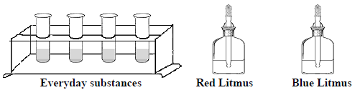Answer the questions below about this investigation.

1. If you used an indicator other than litmus give its name.
2. What is the colour of litmus (or your named indicator) in an acid?
3. What is the colour of litmus (or your named indicator) in a base?
4. Describe how you would test a sample of vinegar to show that it is an acid.
5. What word describes a substance that is neither an acid nor a base?

**The pH Scale**

1. [2008]

The diagram shows the positions of some common substances on the pH scale.

Classify the substances shown as acidic, basic or neutral.

1. [2007]

Name an everyday substance with a pH of less than 7.

|  |  |  |  |  |  |
| --- | --- | --- | --- | --- | --- |
| Substance | Pure water | Household ammonia | Urine | Gastric juice (stomach) | Blood |
| Ph | 7 | 12 | 6 | 1.4 | 7.4 |

1. [2010]
2. What is the pH scale?
3. How can pH be measured?
4. Look at the table and name a strong acid and a weak alkali from it.
5. Select a substance from the list with a pH less than 7 and one with a pH greater than 7: orange juice, rain water, toothpaste, bread soda, vinegar, sour milk, milk of magnesia, cola, washing soda.
6. [2011][2010 OL]

You are given a bottle of vinegar as shown in the diagram.

Describe, with the aid of a labelled diagram, how you would measure the pH of the vinegar.

Use the following headings: Equipment, Procedure, Result



1. [2009 OL]

The diagram shows the apparatus set up by a student to investigate the pH of three different liquids A, B and C.

A few drops of universal indicator were added to each liquid in a test tube.

Study the diagram and the results given. Then answer the questions below.

1. Which test tube, A, B or C, contained distilled water? __________
2. Which test tube, A, B or C, contained an acid? ________________

Give a reason for your answer.

1. [2011]

Complete the equation: 2HCl + CaCO3



**Titration**

1. 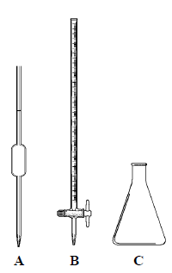[2011]2010 OL][2008 OL][2006 OL][2012 OL]

When hydrochloric acid reacts with sodium hydroxide to neutralise each other, a salt and water are formed. Some of the pieces of equipment used in this experiment are shown in the diagram.

* 1. Name the pieces of equipment labelled A, B and C.
  2. Name the salt formed when sodium hydroxide is neutralised by hydrochloric acid?
  3. Which piece of equipment A or B is usually used to measure the hydrochloric acid during this experiment?
  4. How can you tell by using an indicator that enough hydrochloric acid has been added to neutralise the sodium hydroxide?

1. [2006]

The pieces of laboratory equipment shown, together with some other items, were used to prepare a sample of sodium chloride.

* 1. Name item A or item B
  2. There were 25 cm3 volumes of base used in this experiment.

Describe how the piece of equipment A was used to measure the volume of acid required to neutralise this amount of base.

* 1. Name a suitable acid and name a suitable base for the preparation of sodium chloride by this method.
  2. Write a chemical equation for the reaction between the acid and the base that you have named.

1. [2009]
2. What is item A used for in the titration of an acid with a base?
3. What happens when an acid reacts with a base?
4. [2007]

Give the formula of a common base.

1. [2007]

Alkalis are water-soluble bases. Name a substance, which is alkaline.



1. [2008 OL]

The diagram shows a piece of magnesium being burned in air.

Magnesium oxide is formed.

When magnesium oxide is tested with moist red litmus indicator it changes colour to blue. What does this tell us about magnesium oxide?

**Exam Solutions**

1. Acid - Vinegar

Base – Oven cleaner

1. Equipment and chemicals: Litmus paper / universal indicator / pH paper (meter)

Procedure: Drop a spot of universal indicator onto each substance and note the colour change.

Result: Universal indicator: pH less than 7 in an acid and greater than 7 in a base

1. (i) (ii) (iii)

|  |  |  |  |
| --- | --- | --- | --- |
| Litmus | Methyl orange | Phenolphthalein | Universal |
| Red | Red | Colourless | Red/orange/yellow |

|  |  |  |  |
| --- | --- | --- | --- |
| Litmus | Methyl orange | Phenolphthalein | Universal |
| Blue | Orange/Yellow | Fuchsia/pink | Green/blue/violet |

1. Dip the litmus paper into the vinegar / add a spot of vinegar to the indicator

Match the colour to the appropriate colour on the colour chart

The pH will be less than 7

1. Neutral
2. Battery acid/ sulphuric acid/ vinegar/ lemon (orange) juice/ sour milk/ named carbonated drink
3. Acidic: lemon juice/ soda water

Basic: tooth paste/ lime water

Neutral: pure water

1. It is a scales which indicates degree of acidity or alkalinity of a substance
2. pH paper/ pH meter/ pH probe / universal indicator
3. Strong acid – Gastric juice

Weak alkali – blood

1. pH less than 7: Orange juice/ rainwater/ vinegar/ sour milk/ cola

pH greater than 7: Toothpaste/ bread soda/ milk of magnesia/ washing soda

1. Put the substance to be tested in a container.

Add universal indicator / dip in pH paper / pH probe

Result: Compare to chart / take reading

1. B
2. A, because acids have a pH less than 7
3. 2HCl + CaCO3 CaCl2 **+** H2O + CO2



1. Pipette, Burette, Conical flask
2. Sodium chloride
3. B (the burette)
4. It changes colour
5. A: burette, B: pipette
6. Read volume before and after release

Subtract the second reading from the first

1. Acid: Hydrochloric acid

Base: Sodium hydroxide

1. HCl + NaOH → NaCl + H2O
2. Measure volume
3. **N**eutralisation/ salt is formed/ water formed
4. Ca(OH)2, CaCO3, NaOH, Na2CO3, NH3…
5. Sodium hydroxide (caustic soda)/ sodium carbonate (washing soda) sodium hydrogen (bi) carbonate (bread soda)/ ammonia…
6. It is basic (alkaline)

**Other Test Questions**

1. Complete the chemical equation for the reaction between the acid and base below:

HCl + NaOH +

1. State the name of the following strong acid: H2SO4
2. Give the formula for the base calcium hydroxide.
3. Name an acid and a base commonly found in the school lab.
4. (i) Name two chemicals that are used to prepare a sample of sodium chloride.

(ii) What is the function of the indicator used in the experiment to prepare a sample of sodium chloride.

1. State the approximate pH of hydrochloric acid.
2. State the approximate pH of sodium hydroxide solution.
3. What term is used to describe the reaction when a strong acid is mixed with a strong base.
4. Give an everyday example of a reaction between an acid and a base.
5. (i) Name an indicator.

(ii) What colour will this indicator be in hydrochloric acid?

1. Given a diagram of a pipette and burette

**Extra Stuff**

Hydrochloric acid is very corrosive but can be found in our stomach because it aids digestion.

**Everyday examples of neutralisation**

1. A bee sting (acid) neutralised with baking soda (base)
2. A wasp sting (base) can be neutralised by vinegar (acid)
3. Toothpaste neutralises the acid on your teeth that is produced from bacteria.
4. Antacid neutralises excess acid in the stomach.
5. Lime is used to reduce acidity in soil.

**Salt formed from neutralisation**

The first part of the base name (Na in NaOH) becomes the first part of the salt.

The second part of the acid name (Cl in HCL) becomes the second part of the salt name.

The name of the salt depends on the acid you start with:

Hydrochloric acid → chlorides

Nitric acid → nitrates

Sulfuric acid → sulfates

**Titration - extra**

Slowly add the acid into the conical flask while swirling the flask with your other hand.

When you start to see a pink colour appear where the acid drips, add the acid one drop at a time until the liquid in the conical flask remains pink.

Wash out apparatus and repeat experiment without using the indicator.

Use the measurement from the new reading to get the exact amount needed to neutralise the base.